OUTPUTS OF LAB ASSIGNMENT IN HTML AND CSS

I

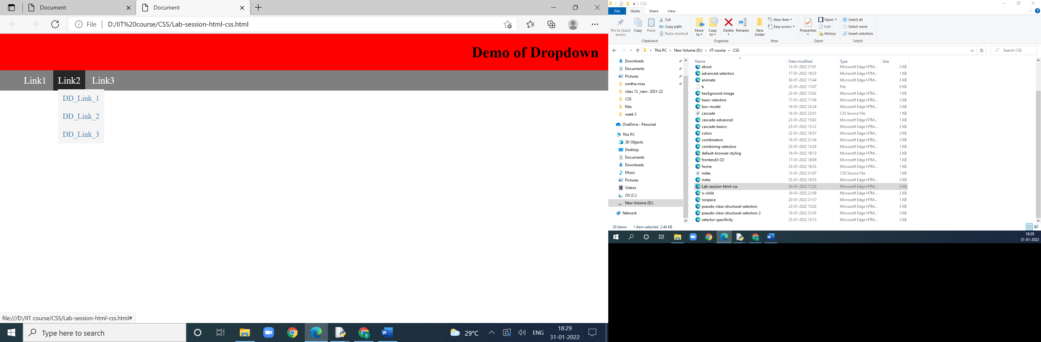

II

